Scanner Class
Scanner class is a predefined class added in Java 5 versions
Scanner class is used to read the values into the variables from keywords during program execution (runtime)
Scanner class is present in java.util.package
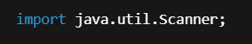
Creating Scanner class object 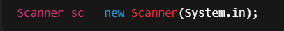
System.in takes input from keyword
sc object reference
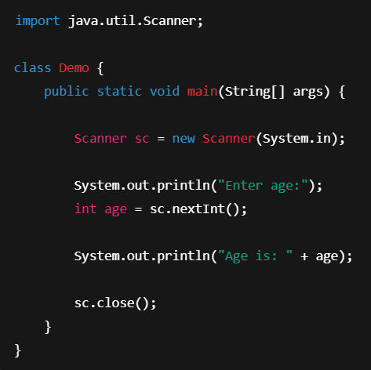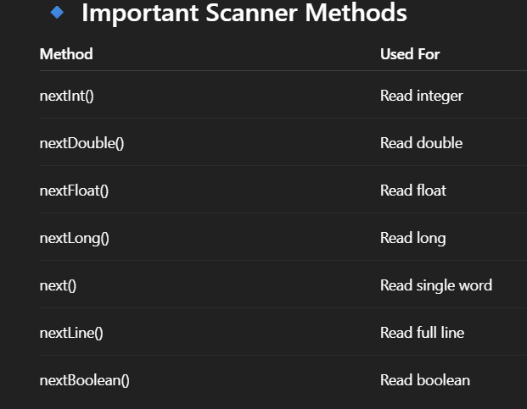

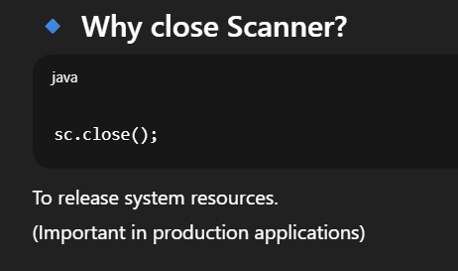
Scanner class is part of java.util package used to take input from various sources like keyboard, file, or string. It provides methods like nextInt(), nextLine(), nextDouble() to read different types of data.

🚀 Backend Developer Note
In real backend applications:
- We don’t use Scanner.
- Input comes from HTTP request (Spring Boot controllers).
- But Scanner is important to understand basic input handling.

